Access Guide

Cinevolution's Digital Carnival Z

Table of Contents
Festival Introduction- Page 2
What is Digital Carnival Z? - Page 2
What is a Land Acknowledgement? - Page 3
Accessibility Introduction - Page 3
Overview of Initiative - Page 3
Acknowledgments - Page 4
Digital Carnival Z - Page 4
Artwork Accessibility - Page 4
Reflection of ME by Natasha “Courage” Bacchus - Page 4
NEW NORMAL: an embodied novel by Margaret Dragu with Justine A. Chambers - Page 5
(un)important, today is by Danielle Long - Page 5
Negev Varod/Seeing Pink by Mickey L.D. Morgan - Page 5
Digital Exploration of the Expansion by Kofi Oduro (Illestpreacha) - Page 6
Let Me In by Juli Saragosa - Page 6
Events - Page 7
Digital Carnival Z Launch - Page 7
Workroom - Page 7
Feminist Craft of Care for Times of Crisis - Page 8
Artist Talk with Nancy Lee 李南屏 And Kiran Bhumber ਕਿਰਨਦੀਪ ਕੌਰ ਭੰਬਰ - Page 8
Visionary Organizing on Social Media:
The Limits and Possibilities of Touch, Tenderness and Timelessness -Page 9
Participation Guide - Page 10
Brave Spaces - Page 10
Recording - Page 10
Website Guide - Page 10
Web Content Accessibility Guidelines - Page 10
Access Control Button - Page 10
Access to Let Me In by Juli Saragosa - Page 11
Richmond Art Gallery Guide - Page 12
UNION Exhibition Information - Page 12
Accessibility Information - Page 12
Address - Page 12
Accessible Entrances - Page 12
Facility - Page 12
Car Parking - Part 12
Bike Rack - Page 13
Public Transportation - Page 13
Washrooms - Page 13
Food and Drinks - Page 13
Seating - Page 13
Service Animals - Page 14
Technical Assistance - Page 14
Zoom - Page 14
Logging in - Page 14
Change Language - Page 15
Join a Webinar - Page 15
Audio Settings - Page 15
Raise Hands - Page 15
Chat - Page 16
Pin Video - Page 16
Change View - Page 16
Zoom Tips - Page 16
YouTube - Page 17
Captioning - Page 17
Definitions - Page 18
Credits - Page 20
Funders and Sponsors - Page 21

Festival Introduction

What is Digital Carnival Z?
Digital Carnival is a festival of media art. The festival is focusing on community audiences who have historically been left out of art spaces. This includes immigrants, newcomers, LGBTQ2S+, low-income families, and people who are often forgotten because they have been ‘othered.’
This year, the theme of the festival is ‘Z’. The letter refers to both Generation Z, a generation born in the late 1990s who are known as the "digital natives," and the pronoun 'zie,' a gender-neutral word that is sometimes used in place of he, she, they, or another pronoun. With this theme, artworks will explore different understandings of the relationship between bodies, gestures, culture, and society. The festival creates space for artists to make work that responds to our shifting social, environmental, physical, and emotional realities.
Due to the restrictions imposed by COVID, Digital Carnival Z will take place both in-person and online. The featured artist exhibition, titled UNION, by Nancy Lee and Kiran Bhumber will take place at the Richmond Art Gallery. The rest of the participating artists will be available for viewing virtually at www.digitalcarnival.ca from April 21st to June 5th.
True to the low-barrier spirit of the festival, this year’s festival has been developed with a focus on digital accessibility. Each artist has considered accessibility for various disability communities within the context of their work.

What is a Land Acknowledgement?
A land acknowledgement is an opening recognition that understands the longstanding history of the land which you reside on. It also acknowledges your place in that history.

Cinevolution Media Arts Society is situated on the occupied, traditional and ancestral territories of the hǝn̓q̓ ǝmin̓ ǝm̓ speaking peoples, including the xʷməθkwəy̓əm (Musqueam) and other Coast Salish peoples.

Because much of Digital Carnival Z is taking place online, Cinevolution wants to consider the legacy of colonization set within technologies, structures and ways of thinking and doing that we’re currently using.

The festival is using equipment and high-speed internet that are not available in many Indigenous communities. These technologies leave significant carbon footprints contributing to changing climates that are disproportionately affecting Indigenous peoples worldwide. We ask that you acknowledge that we all are sharing this responsibility to reconsider our roles in reconciliation, decolonization, and allyship in relation to Indigenous communities in what is now known as Canada and across the world.

Accessibility Introduction

Overview of Initiative
COVID-19 has changed the arts landscape. Many organizations have turned their exhibitions, performances, and events to an online format. However, many of these digital events fail to address different access needs.

True to the low-barrier spirit of the festival, this year’s festival has been developed with a focus on digital accessibility. Cinevolution is grateful to have worked in consultation with individuals with disabilities and organizations focusing on disability services for the past year. They have offered points of view that have provided access to programming without the need for request.

Our approach to accessibility negotiates the boundaries between creative expression and accessible communications. We are also focusing on building capacity for disability culture. Our goal is for broader visibility and greater integration into everyday lives.

Cinevolution understands that access needs are different for everyone and that these needs can also change every day. We will do our best to accommodate your needs before you even attend our programming. However, if there are additional accessibility needs, we will try our best to accommodate. For more information or specific requests, please contact Regan Shrumm, our Accessibility Coordinator, at (778) 803-7150 x 105 or regan@cinevolutionmedia.com.

Acknowledgments
Accessibility Consultants
Ladan Sahraei, Carmen Papalia, Amy Amantea, George Quarcoo, Lauren Wu, Vivian Chong

ASL Interpreters
Lily Flanjak, Lisz Keallen, Jenny Laing, Larissa Peters
Audio Describers: Cheryl Green, Rebecca Singh, James McKenzie (Apprentice)
Captioners: Jennifer Chadwick, Jenniffer Tai,
Translators: Sean Cao, Madhvi Dhaumya, Henry Heng Lu, Keying Wu

Accessibility Partners
ASL Interpreting Inc.
Kudoz
Island Deaf and Hard of Hearing
Superior Description
VocalEye
Wavefront Centre for Accessible Communications

Thank you to our research working group participants, including David Araniva, AJ Brown, Adrian Chow, Ronald Fee, Leila Fredland, Tami Grenon, Richard Harlow, Richard Marian, Bill Parker, Albert Ruel, and all of our Kudoz working group participants.

Special thanks to Jai Djwa, Pam Khinda, Steph Kirkland, Ish Kumar, Sean Lee, Yat Li, Sage Lovell, Janey Roh, Surendal Pal Singh, Iver Smith, Gordon Tulloch, Jenn Wilson, Melody Wise, and everyone who shared their insights and advice with us.

Digital Carnival Z

Artwork Accessibility
There are six artworks available through www.digitalcarnival.ca. Each artwork has its own accessibility accommodations. All artworks have a full transcription.

Reflection of ME by Natasha “Courage” Bacchus

Courage is a Tkaronto-Guyanese Black Deaf Queer Female, and former Deaf Olympian. Her new video work, Reflection of ME, shares her experiences of personal trauma within the broader context of a white, patriarchal, colonial society.

Content warning: The video references the artist’s personal experiences of racism and heteropatriarchy. Words may be triggering or uncomfortable for certain audiences.

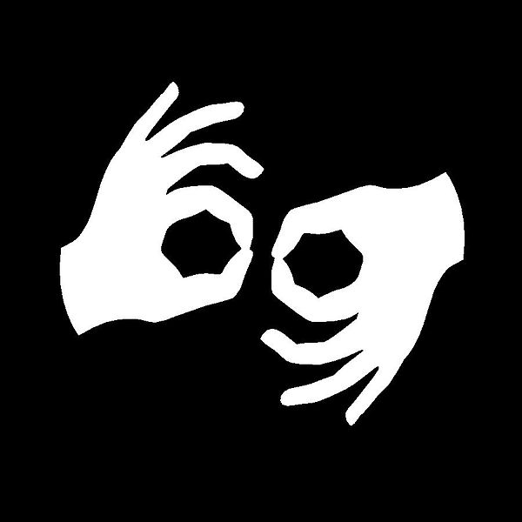

NEW NORMAL: an embodied novel by Margaret Dragu with Justine A. Chambers

Margaret Dragu maps her experience of moving through the public sphere as a person with a mobility issue. Alongside dance artist Justine A. Chambers, they create an immersive installation that explores the social architecture of ability through video, performance, music and text.

(un)important, today is by Danielle Long

A queer emerging contemporary dance artist and self-taught filmmaker, Danielle Mackenzie Long creates the interdisciplinary experimental movement short film (un)important, today is using physical movement to highlight the exploration and declaration of self.

Negev Varod/Seeing Pink by Mickey L.D. Morgan

Practicing the oral-written paired tradition of Judaism with an emphasis on translating for multiple points of access, Negev Varod/Seeing Pink is a scroll-format and audio-collage poem focused on pink-washing, the act of propagandizing 2LGBTQ+ acceptance in order to obscure systemic violence.

Digital Exploration of the Expansion by Kofi Oduro (Illestpreacha)

Montreal-based creative coder and engineer, thinker, poet, and performer Kofi Oduro's (Illestpreacha) Digital Exploration of the Expansion is a presentation and performance of a speculative fiction through live coding, creative coding, and other mediums that explores how the body can be reimagined.

Content warning: The video has flashing strobe light that could trigger photosensitive epilepsy.

Let Me In by Juli Saragosa

Let Me In is an interactive web-based queer ASMR (Autonomous Sensory Meridian Response) piece using acoustic close-ups to show how the sum of the parts of a queer body, visible and audible, is read subconsciously in order for a perception of queerness or gender to be made.

Content warning: The video has flashing strobe light that could trigger photosensitive epilepsy.

Events

Digital Carnival Z Launch
Date: Wednesday, April 21st, 6:30 pm to 8:00 pm PST
Platform: Zoom
Registration: https://dczlaunch.eventbrite.ca
Featuring: Nancy Lee 李南屏, Kiran Bhumber ਕਿਰਨਦੀਪ ਕੌਰ ਭੰਬਰ , and Kofi Oduro (Illestpreacha)

Description: This event will include a traditional welcome and land acknowledgement, a special appearance by featured artists Nancy Lee 李南屏 and Kiran Bhumber ਕਿਰਨਦੀਪ ਕੌਰ ਭੰਬਰ, as well as a live creative coding performance by Kofi Oduro (Illestpreacha).

Accessibility: ASL interpretation, Audio Description, automated captions in English.

Documentation: The event will be recorded, and an English transcript will be made available with the recording after the event.

Workroom
Date: Friday, May 7th, 6:30 pm to 8:00 pm PST
Platform: Zoom
Registration: https://dczworkroom.eventbrite.ca
Featuring: Skim and Rye

Description: Drag shows, parties, raves and now drag Zoom rooms. Who are these events accessible to? Where do folx feel they belong and when do they feel gender dysmorphia/euphoria? Workroom is a discussion space for people to explore drag, gender, and the challenges of being seen in digital and analog spaces.

The event is hosted by Skim and Rye, and open to all to attend, observe, and contribute.

Accessibility: ASL interpretation, live captioning services, and descriptive language

Documentation: This event will not be recorded.

Feminist Craft of Care for Times of Crisis
Date: Thursday, May 13, 6:30 pm to 8:00 pm PST
Platform: Zoom
Registration: https://feministcraftofcare.eventbrite.ca
Featuring: Lena Chen, Mallory Donen, and Sarah Shamash
Moderator: Minah Lee

Description: How have the labours of women artists been affected by the challenges of the ongoing pandemic? By centring feminist understandings of connections, can we resist the normalized and privileged cruelties practiced by capitalist patriarchy in these unprecedented times? This panel invites you to the works of Lena Chen, Mallory Donen, and Sarah Shamash, three women artists who are crafting "care culture" in their communities through their art practice and subverting the expected outcomes of feminized labours. Threading together realities of gender, labour, and surveillance, the artists' dialogue will expose gendered bodies in resistance.

Accessibility: ASL interpretation, descriptive language, and automated captions in English.

Documentation: The event will be recorded, and an English transcript will be made available with the recording after the event.

Artist Talk with Nancy Lee 李南屏 And Kiran Bhumber ਕਿਰਨਦੀਪ ਕੌਰ ਭੰਬਰ
Date: Saturday, May 15, 2:00 pm to 3:30 pm PST
Platform: Zoom
Featuring: Nancy Lee 李南屏 and Kiran Bhumber ਕਿਰਨਦੀਪ ਕੌਰ ਭੰਬਰ
Moderator: Yun-Jou Chang
Co-presented with the Richmond Art Gallery

Description: In conjunction with UNION, artists Nancy Lee 李南屏 and Kiran Bhumber ਕਿਰਨਦੀਪ ਕੌਰ ਭੰਬਰ will share the impetus for the exhibition, the core themes that shaped the world of UNION, their history of creative collaboration, and their experiences in developing the project. The talk will be moderated by Cinevolution Media Arts Society Executive Director Yun-Jou Chang.

Participants will have the opportunity to ask questions and interact with one another in real time.

Accessibility: ASL interpretation and closed captioning in English

Visionary Organizing on Social Media:

The Limits and Possibilities of Touch, Tenderness and Timelessness
Date: Thursday, May 20, 6:30 pm to 8:00 pm PST
Plaform: Zoom
Registration: https://visionaryorganizing.eventbrite.ca
Featuring: Angelic Proof and Gina Goico

Author Grace Lee Boggs spoke of the need for "visionary organizing" in times of crisis. Through the limits of the continual global crisis, much social organizing has occurred exclusively within the online space. Angelic Proof and Gina Goico, two media artists, activists and scholars - look towards the capacities of "visionary organizing" within social media spaces.

They ask: what does it take to sustain and build a nurturing culture in online space? What are the future visions of digital freedoms that challenge norms of organizing and archives that lead to an evolving map towards sustained legacies of queer, trans, Black, Indigenous, and other marginalized publics?

Goico and Proof will share mini-lectures, texts, and interactive activities for everyone to participate and imagine what it takes for the possibilities of touch, tenderness, and timelessness to exist online.

Accessibility: ASL interpretation, descriptive language, automated captions in English.

Documentation: The event will be recorded, and an English transcript will be made available with the recording after the event.

Participation Guide

Brave Spaces
- Cinevolution wants to make sure that you have as comfortable experience as possible. Here are some helpful tips:
- You do not need to stay for the entire session if you don’t want to
- Make sure you have some snacks and water around you
- Wear comfortable clothing
- You do not need to have your camera on if you don’t want to
- Turn down the brightness on your computer screen
- Sit however you want, even if you are on camera
- Have blankets and sweaters around you to help control your temperature

Some content in the festival can be upsetting (content warnings have been provided). If you have been upset by content, here are some suggestions to help calm yourself:
- Call or text your social support
- Deep breathing
- Write in a journal
- Go for a walk

Recording
Please note that all Zoom events will be recorded, except for Workroom. The recordings may be used for documentation and re-used for marketing platforms.

Website Guide

Web Content Accessibility Guidelines

The Digital Carnival website was built to pass the set requirements of the WCAG or Web Content Accessibility Guidelines’ 2.0 standards. The WCAG guidelines were made to help make the internet more user friendly for everyone. Cinevolution recognizes that the WCAG does not address all needs. In fact the WCAG can even be problematic, such as the fact that you do not need to caption podcasts since they are not considered multimedia.

Access Control Button

On the top, right hand side, there is a white button with a figure raising its hands in the air. This is the access control button. When you click on the button, a drop down menu will appear. You can select from four different options.

The first selection is "Font Resize" where you can increase the font size by clicking on the "A+" button and decrease by clicking on the "A-" button. The second selection is "Reset Font Size," which will change the font back to the default size. The third selection is "Readable Font," which will bold, enlarge, and increase the colour contrast of the font to make it easier to read. The fourth selection is “Underline Links,” which will underline all links to other web pages. The fifth selection is "Images Greyscale," which will turn the entire website into various gradients of grey. The final selection is "Reset Settings," which will turn things back to the way it was.

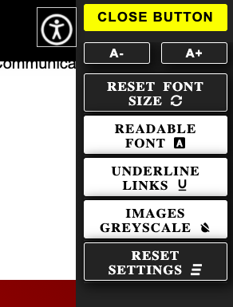
Image: Access Control Buttons that depicts all of the access buttons for the website.

Access to Let Me In by Juli Saragosa

Let Me In by Juli Saragosa can be accessed through the Digital Carnival Z website. However, this artwork has limited accessibility on the website. To get a more accessible version of Let Me In, there is an app that can be downloaded through Google Play or the Apple Store.

Richmond Art Gallery Guide

UNION Exhibition Information

UNION is an exhibition with artists Nancy Lee 李南屏 and Kiran Bhumber ਕਿਰਨਦੀਪ ਕੌਰ ਭੰਬਰ. It is presented at the Richmond Art Gallery.

Set in the year 3000, UNION imagines a world in which the nation has fallen apart. The air pollution limits liveable space and physical contact. In 2024, there is a year-long worldwide blackout. This causes all digital information to be lost, and most print materials have been used for fuel. Humans are physically isolated but connected via the new cyberworld. Touch has become forbidden. Access to cultural memories have been lost. UNION is about two people discovering their ancestral memories through the longing for touch. They practice rituals during their post-apocalyptic wedding ceremony.

Individuals visiting the exhibition will experience this new world through a short film, 3D printed sculptures, propaganda posters, two futuristic bridal dresses, interactive sound and visual projection map installation.

Accessibility Information

Address
The Richmond Art Gallery is located at 7700 Minoru Gate between Granville Avenue and Minoru Boulevard. It is located inside the Richmond Cultural Centre.

Accessible Entrances
The main entrance at Minoru Plaza has five steps and is accessible with ramp entry. The main entrance has automatic sliding doors. The entrance on the eastside of the building on Minoru Boulevard has six stairs and is accessible with a ramp. This entrance has an automatic push plate/button entrance.

Facility
The Richmond Art Gallery is located on the main floor of the Richmond Cultural Centre. Inside the gallery, halogen and LED lighting are used throughout. All door handles inside the gallery are lever style. While there is no lockers or coatroom, there are coat hooks available at the entrance. The items are left at the owners’ risk.

Car Parking
Designated accessible parking is located at ground level in the parkade adjacent to the Richmond Cultural Centre. Four spots are accessible, with two providing van access. Additional accessible parking is located throughout the complex, including near entrances at the Richmond Arena, Minoru Aquatic Centre, and Minoru Track.

Bike Rack

There are three bike racks located by the main entrance on the Minoru Plaza. One bike rack is located by the east entrance on Minoru Boulevard.

Public Transportation
The Gallery is located near the following bus stops:
- The Minoru Gate and Minoru Boulevard bus stop serves line 414.
- The Granville Avenue and Minoru Boulevard bus stop serves line 406.
- The No. 3 Road and Park Road bus stop serves line 402, 403, 404, 406, 410, 414, and 416.

All TransLink buses are wheelchair accessible with 80% of transit stops designated as accessible. For handyDART, TransLink’s accessible, door-to-door shared transit service, please contact TransLink at call 604-575-6600 (local) and 1-844-475-6600 (toll-free).

The closest SkyTrain station to the Gallery is Richmond-Brighouse, which is 1.1 km away from the Gallery.

Washrooms
Public washrooms at the Richmond Cultural Centre are on the main level to the right of the Information Desk. Men's and women's facilities both include an accessible stall with grab bars. The second floor has both gendered washroom facilities, and an universal washroom with grab bars. All washrooms have baby changes tables, and soap and air dryers are at lower height.

Food and Drinks
Currently, there is no food or drinks available for purchase within the Richmond Cultural Centre. Outside food and drinks are allowed in the Richmond Cultural Centre; however, no food or drinks are permitted in the Richmond Art Gallery. Water fountains are located on the main and second floors of the Richmond Cultural Centre.

Seating
Seating is currently limited due to Provincial Health Orders. Bench seating (without arms) is available in the lobby of the Richmond Cultural Centre.

Service Animals
Service animals are welcome.

Technical Assistance

Zoom

Logging in
If Zoom is not already installed, download the Zoom application from the following web site and select "Save File" from https://zoom.us/download. Locate the Zoom download file in your "Downloads" folder and double click on it to carry out the install. Click on Continue when prompted.

Click on "Sign In" when the Zoom screen appears. If this screen doesn’t appear, go to your "Applications" folder and double click on the zoom.us application.

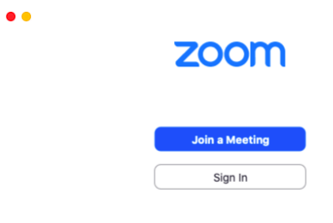
Image: Zoom's introduction screen with the "Sign In" button highlighted in a red box.

If you have not already signed up, click on "Sign Up for Free." You can also sign in or sign in via Google or Facebook..

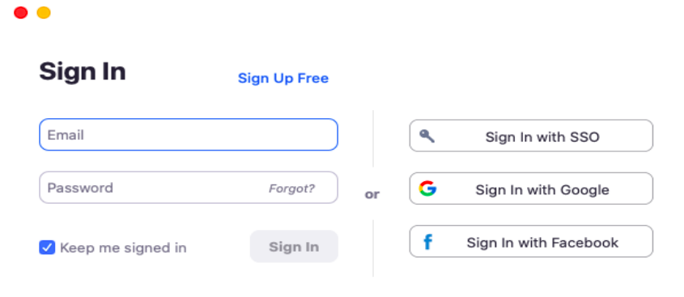
Image: Zoom's sign in screen where individuals can sign in via email or sign up for Zoom.

Change Language
If you need to change the language of your Zoom application, find the application on your desktop. Open Zoom. Then right-click on the Zoom icon. There should be an option to change the language in this drop-down menu.

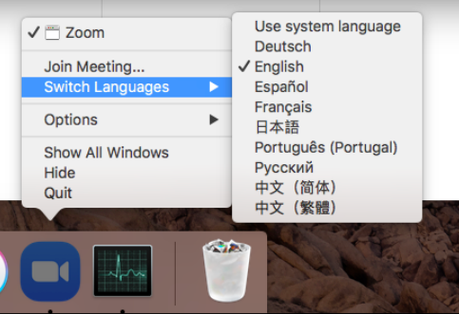
Image: The switch language feature for Zoom.

Join a Webinar
To join the webinar, click the link that the host provided you or that you received in the confirmation page after you registered. On webinar, you will not be able to have your camera on.

Audio Settings
You will not be able to control your microphone unless the host gives you permission. If they do give you permission, you can mute and unmute your microphone using the mute button on the lower left hand side of the screen. The host also has the ability to mute you.

Raise Hands
Raise your hand in the webinar to indicate that you need something from the host. To raise your hand, go to the options bar on the bottom of the screen. Select the "Reactions" button, and then select the "Raise Hand" button.

The host may instruct you on how they plan to use this. Many webinar hosts use this feature to know if an attendee has a question and would like to speak out loud.

Chat
Cinevolution acknowledges that chat functions on Zoom can be a mixed bag of accessibility depending on your needs and/or disability. For some, the chat is a way to comfortable communicate in a safe way. For others, they are using a form of technology, such as a screen reader, which will read out everything that is written in the chat, making it very difficult to concentrate. We ask individuals using screen readers turn them off during the events if they choose.

The moderator will be reading comments in the chat aloud when it is meant for the group, therefore making sure that all will hear what is being discussed in the chat.

Pin Video
As a participant, you can pin a particular video so Zoom will highlight that video rather than switching between the active speaker video. You can pin a video by right-clicking on the video of the person you want to pin or double click on their video window.

Change View
At the top right of the screen, you can enter or exit the full screen mode. You can also change the view from speaker view or gallery view. With "Speaker View," Zoom enlarges the video for the person who is currently speaking or for the person whose video you have pinned. With "Gallery View," you will see a grid of thumbnail displays of all the participants. If there are more than 49 participants, there will be additional pages of the thumbnail displays.

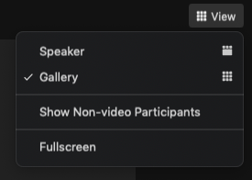
Image: The view settings feature for Zoom.

Zoom Tips
To ensure a strong Zoom connection:
- Close excess tabs on your internet browser
- Clear your browser cookies (small pieces of data stored on a person’s computer while they search the internet)
- Ask others in your household to not stream media at the same time

YouTube

Captioning

You can change the size, font, and colour of the captioning on Youtube. Click on the settings wheel on the lower right hand side of the YouTube video you are watching. Click on the "Subtitles/CC" button.

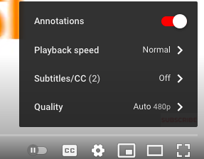
Image: The setting options for YouTube.

Once on the "Subtitles/CC," click on the "Options" button which is on the upper right hand corner of the settings menu.

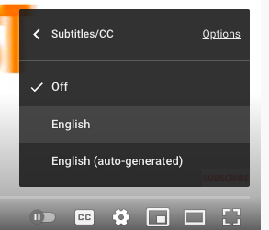
Image: The "Subtitles/CC" button for YouTube.

From there, you have many different options to choose from font, font colour, font size, and many other alternatives.
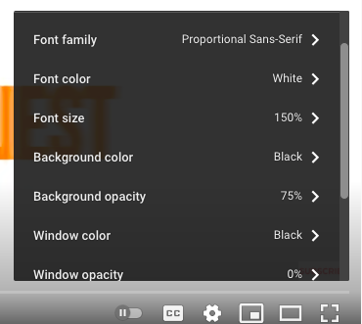
Image: The "Subtitles/CC options" button for YouTube.

Definitions

ASL
A short way of saying American Sign Language. It is the most widely used sign language for the Deaf community in the United States, English-speaking parts of Canada, and parts of Mexico.

ASMR
Autonomous sensory meridian response (or ASMR) is a tingling sensation. It often starts on the scalp and moves down the back of the neck and upper spine. It is often set off by some auditory or visual stimuli.

Airpocalypse
An extreme event involving air pollution.

Ashkenazi Jews
Jewish people who live(d) in Central and Eastern Europe after being exiled by the Romans from what was then Judea. The traditional conversational languages used are Yiddish dialects.

Audio Description (AD)
The descriptive narration of key visual elements of media to enhance the enjoyment by consumers who are blind or have low vision.

BIPOC
A short form way of saying “Black, Indigenous, and People of Colour.”

Closed Captions
A synchronized transcription of speech and written descriptions of relevant audio elements that are visible only when selected.

Content Warning
A written or verbal notice that precedes potentially sensitive content. The notice flags the content so that people can prepare themselves or disengage themselves, if needed.

Creative Coding
A type of computer programming where the goal is to create something expressive rather than something functional.

Crip
A term reclaimed by people with disabilities that was originally slang for the derogatory term cripple. Crip includes people who experience any form of disability, is often associated with disability activists and disability rights.

Cyberworld
An online environment where people are involved in social interaction.

Diaspora
A population of people whose origin lies in a separate geographic location.

d/Deaf
Deaf with a capital “D” refers to Deaf identity and culture, while deaf with a lower-case “d” refers to the experience of not hearing.

Gender Dysphoria
A term used to describe people who have feelings of discomfort or distress around their gender identity being different than the one assigned at birth.

Heteropatriarchy
A society or culture dominated by a ruling class of heterosexual males whose characteristic bias is unfavorable to people in the LGBTQ2+ community and genders other than male.

LGBTQ2+
A short form way of saying standing for lesbian, gay, bi, trans, queer, and two-spirit.

Mizrachi Jews
Jewish people who live(d) in the Middle East and North Africa. The traditional conversational languages used are Farsi and various Arabic dialects.

Non-Binary
A term used by some people to describe gender identity/ies not fitting into traditional gender categories of male/female.

Pinkwashing
A term used to describe the action of using queer-positivity in order to distract attention from negative actions by an organization, government, and/or individuals.

Projection Mapping
A video technique used to turn objects into a display surface for video projection.

Settler
A word used by some people to acknowledge their ancestors' and their own continued colonization and occupation of Indigenous land.

Transcript
A written or printed version of material originally presented in another medium.

Queer
A term reclaimed by LGBTQ2+ communities that was a derogatory term. Queer has many definitions, but is generally used as an umbrella term for the wide spectrum of sexual orientations and gender identities.

Unceded and traditional territories
Unceded territories means the land that Indigenous peoples never legally signed over to the Crown or to Canada. Traditional territories are the lands identified by Indigenous peoples as the land that they and/or their ancestors used and occupied.

Yiddish
A language family used by some Ashkenazi Jewish individuals with several distinct regional and familial dialects. It is written in the Hebrew alphabet and derived from High German, Hebrew, and neighbouring languages. Yiddish also means Jewish in Yiddish.

XR
XR is acronym for “Extended Reality.” The term refers to any sort of technology that alters reality for an user by blurring the line between the real and digital worlds. XR technologies include augmented reality and virtual reality technologies.

Credits
Festival Team:

Executive Director: Yun-Jou Chang
Associate Curator: Minah Lee
Operations Manager: Jenniffer Tai
Accessibility Coordinator: Regan Shrumm
Marketing Coordinator: I-Chen Hsu
Lead Developer: Deanne Achong
Mobile Developer: Gunwoo Kim
Production Manager: Jian Ping Su
Artistic Advisor: Wynne Palmer

Board of Directors:

Ying Wang (President), Lynn Chen, Tyler Russell

Special Thanks:

David Araniva, AJ Brown, Matthew Brown, Adrian Chow, Nan Capogna, Shaun Dacey, Jai Djwa, Ronald Fee, Leila Fredland, Tami Grenon, Richard Harlow, Pam Khinda, Steph Kirkland, Ish Kumar, Sean Lee, Yat Li, Sage Lovell, Richard Marian, Bill Parker, Albert Ruel, Janey Roh, Surendal Pal Singh, Iver Smith, Gordon Tulloch, Kathy Tycholis, Jenn Wilson, Melody Wise, and all of our Kudoz working group participants.

Funders and Sponsors
Government of Canada
Canada Council for the Arts
Canada Media Fund
Disability Alliance BC
BC Arts Council
Government of BC
TD Ready Commitment
City of Vancouver
City of Richmond
Business Arts
Sundance Institute

